Lab 05 - CSMA/CA study using ns3
Today’s Lab is ungraded. Collaborating and helping each other is encouraged, but there is zero point in copy-pasting answers here without understanding. Use today’s time to learn the skills that will be tested in Lab 06 (Lab Quiz 2).

First finish up Lab 04: Sliding windows using ns3
- CBR and FTP Flow Baseline:
Continuing last week’s exercises, now merge the two ns3 simulations so that both flows are activated on the source node. Configure start/stop times such that both the CBR and FTP flows are running simultaneously for during the simulation.
Set the CBR flow rate such that if running by itself, its throughput would be about 10% of the data rate of the link.
For the FTP flow, set t the TCP receive buffer size to the value which gives you the maximum throughput when the FTP flow is by itself. Make sure the FTP data transfer size is large enough that it occupies the whole simulation time.
Calculate CBR throughput, CBR delay, FTP throughput, FTP Delay
Note all the flow parameters, and the corresponding metrics below:

- Impact of high CBR on FTP
Keep increasing the CBR flow offered* rate and see its impact on the FTP flow throughput and delay. Do not change any ftp flow parameter.
*Offered rate means the rate that a flow “offers” i.e. brings to the network. This is different from the rate (throughput) it will actually get.
Increase CBR data rate so that goes from 10% of the link capacity to 100% capacity, in steps of 10. Tablulate the four metrics above as a function of this data rate and also plot them. Plot both the througputs on one graph and both the delays on another graph.
  - Tablulate the four metrics above as a function of this data rate and also plot them (best to use a spreadsheet). Copy-paste the table below:.

  - Plot both the througputs on one graph and both the delays on another graph as a function of the data rate. Copy-paste the plots below:

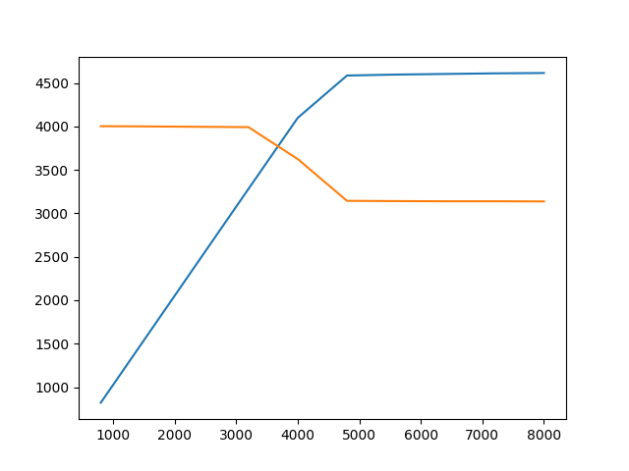
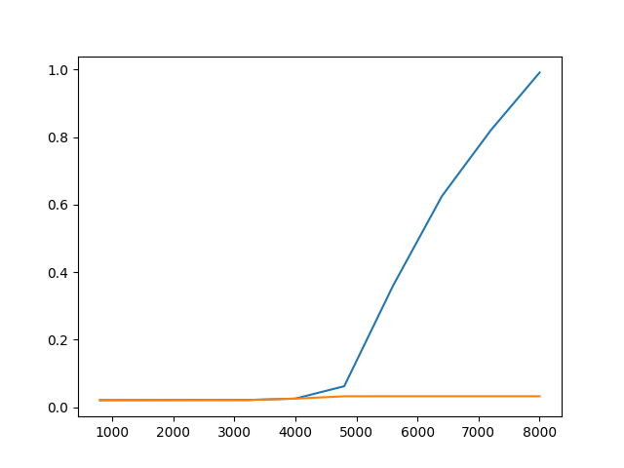
  - Write down conclusions regarding how
    - The increase affects CBR’s own throughput and delay (and why)

    - How the increase affects FTP’s throughput and delay (and why)

IEEE 802.11 CSMA/CA study with ns3

- Download the ns3 code file lab05-wifi-2hidden-stns.cc. This file models 3 stations n0, n1 and n2, in a configuration such n1-n0 can hear each other, n2-n0 can hear each other, but n1 - n2 cannot. Thus n1, n2 are hidden terminals w.r.t. each other.
Study the code - it is well-commented, make sure you understand every line. The basic concept of an abstract helper object which gets installed on some concrete object representing an actual networking entity is the same as you studied in the previous lab. Move the file to scratch directory and run it as you learnt in the previous lab. Now answer the following questions (download this as odt, and answer by making space below the question). Wherever applicable answer all questions for with and without RTS/CTS.
  - What is the mechanism used in the code to achieve the topology of ‘hidden-ness’ vs reachability of the nodes?
lossmatrix
  - Which particular one of the 802.11 family of protocols is selected in this simulation (for PHY layer)
802.11a
  - What is the data rate of the channel?
54Mbps
  - What is the flow configuration? (Who’s sending what to whom?)
flow1--> node1 to node0
flow2--> node2 to node0
  - What are the flow parameters?
Payload-->2200
datarate-->10Mbps
  - For the above parameters, what’s the per node throughput? What’s the total channel throughput?
Without RTS/CTS
Node1-->9.71Mbps
Node2-->9.37Mbps
Node0-->19.09Mbps
Total Channel throughput-->19.09Mbps
With RTS/CTS
Node1-->10.113Mbps
Node2-->10.096Mbps
Node0-->20.2Mbps
Total Channel throughput-->20.2Mbps

  - Change the values so that the total data rate offered to the channel is about 10% of the channel data rate, equally divided among all sources. Keep increasing it to 20%, 30% … 90%. What’s the maximum throughput achieved for each value? What is the trend of the throughput vs offered load? Tabulate/plot the values and paste here.(For these experiments you may want to change the code to take values as input, not hardcoded, else recompiling will take time).

Data Rate | Throughput rts | Throughput~rts
5.4 | 10.83 | 10.91
10.8 | 19.8 | 21.44
16.2 | 19.912 | 22.27
21.6 | 19.917 | 22.32
27 | 19.96 | 22.12
32.4 | 20.1 | 22.27
37.8 | 19.86 | 22.198
43.2 | 19.7 | 22.157
48.6 | 19.8 | 22.21
54 | 19.91 | 22.3

  - Find out the maximum throughput possible when there is no contention (only one source).
25.73 without RTS/CTS and 22.69 with RTS/CTS

  - Make any observations of the numbers with and without RTS/CTS
Throughput without rts is greater because some delay happens in sending RTS and recieving CTS which is un-necessary.

  - RTS/CTS was designed mainly to solve the hidden terminal problem. So perhaps it is not very useful when there aren’t hidden terminals? Modify the code and design and run experiments to validate/invalidate this hypothesis. Paste all results and conclusions below:

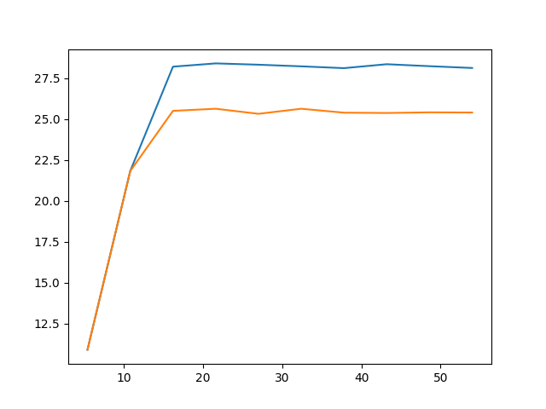

- Modify the code to model a given M number of source nodes in the configuration that n1,....nM are all sending data to n0. Let all of n1...nM be hidden from each other. Each one can be just like the source nodes n1,n2 in the given file. Study the following - again, with and without RTS/CTS, and in fact whereever applicable study what effect RTS/CTS has on the throughput.
  - Total channel throughput as a function of increasing number of nodes. Start with each node bring a low offered rate (e.g. only 2Mbps).Paste the table and plot here.

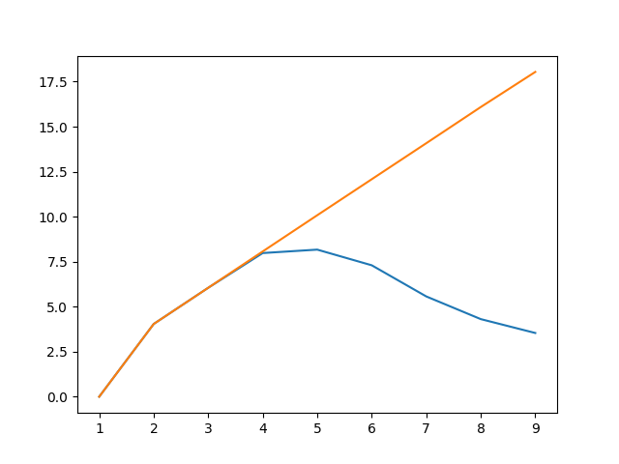

  - Now make all n1 to nM such that they are no longer hidden - all are audible to each other. Now do the same analysis, and compare with when hidden and RTS/CTS effect on the throughput in both case.

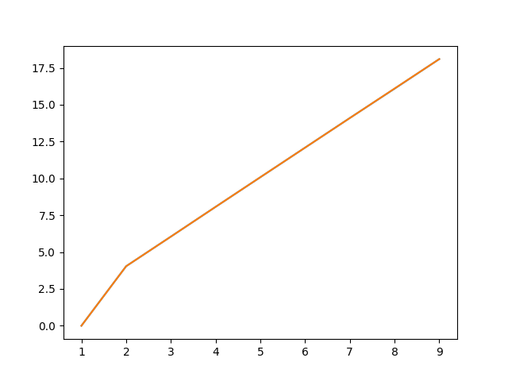

Submit your code and this file (as pdf) by tarring it info a file lab05.tar and upload on Bodhiitree.

